CANDIDATE NAME ____________________________ CLASS________
 | DUNMAN HIGH SCHOOL (SENIOR HIGH)  YEAR 6 PRELIMINARY EXAMINATION 2010
 | H1 CHEMISTRY  Paper 1 Multiple Choice | 8872/01  22 September 2010  50 minutes
Additional materials:
Optical Mark Sheet
Data Booklet

INSTRUCTIONS TO CANDIDATES
- Write your name and class on this question paper.
- There are thirty questions on this paper. Answer all questions. For each question there are four possible answers A, B, C and D.
Choose the one you consider correct and record your choice in soft pencil on the separate Optical Mark Sheet.
- Each correct answer will score one mark. A mark will not be deducted for wrong answer.
- Any rough working should be done in this booklet.
- You may use a calculator.
Section A

For each question, there are four possible answers A, B, C, and D. Choose the one you consider to be correct.

1 | Heating phenylethanone, C₆H₅COCH₃ with iodine and an aqueous alkali yields 12.0 g of triiodomethane. What is the mass of phenylethanone that has reacted?
 | A | 0.36 g | B | 1.80 g | C | 3.65 g | D | 7.20 g

2 | Acidified aqueous sodium dichromate (VI) and acidified aqueous potassium manganate (VII) each liberates iodine from aqueous iodide.  Cr₂O₇^{2–} (aq) + 14H⁺ (aq) + 6e → 2Cr³⁺ (aq) + 7H₂O (l)  MnO₄– (aq) + 8H⁺ (aq) + 5e → Mn²⁺ (aq) + 4H₂O (l)  2I– (aq) → I₂ (s) + 2e  25.0 cm³ of acidified Na₂Cr₂O₇ liberate the same quantity of iodine from a solution of potassium iodide as 25.0 cm³ of 0.030 mol dm^{–3} KMnO₄. What is the concentration of Na₂Cr₂O₇ in mol dm^{–3}?
 | A | 0.015 | B | 0.025 | C | 0.030 | D | 0.050

3 | 10 cm³ of a gaseous hydrocarbon are mixed with 70 cm³ of oxygen and the mixture explodes. After cooling to room temperature, the residual gas occupies a volume of  50 cm³. Upon shaking these gases with aqueous potassium hydroxide, the final volume of gas remaining is 20 cm³. What is the molecular formula of the hydrocarbon?
 | A | C₂H₄ | B | C₂H₆ | C | C₃H₆ | D | C₃H₈

4 | The use of Data Booklet is relevant to this question.  The successive ionisation energies, in kJ mol^{–1}, of an element X are given below.  870 1800 3000 3600 5800 7000 13200  What is X?
 | A | ₃₃As
 | B | ₅₃I
 | C | ₈O
 | D | ₅₂Te

5 | What is the electronic configuration of vanadium atom, with proton number 23?
 | A | 1s²2s²2p⁶3s²3p⁶3d⁵
 | B | 1s²2s²2p⁶3s²3p⁶3d⁴4s¹
 | C | 1s²2s²2p⁶3s²3p⁶3d³4s²
 | D | 1s²2s²2p⁶3s²3p⁶4s²4p³

6 | Compound A is a coloured compound of iron which has the formula [Fe(NH₃)₄][FeCl₄]. The compound is ionic and the oxidation number of the iron is the same in each ion.  What are the formulae of the two ions present?
 | A | [Fe(NH₃)₄]⁺ and [FeCl₄]–
 | B | [Fe(NH₃)₄]²⁺ and [FeCl₄]^{2–}
 | C | [Fe(NH₃)₄]³⁺ and [FeCl₄]^{3–}
 | D | [Fe(NH₃)₄]⁴⁺ and [FeCl₄]^{4–}

7 | Hydrogen trioxide, H₂O₃, is an unstable compound but can be isolated in small quantities. Carbon suboxide, C₃O₂, is a foul–smelling gas obtained by fully dehydrating  propan–1,3–dioic acid. Which of the following shows reasonable Lewis structures for these two molecules?
 |  | Hydrogen trioxide | Carbon suboxide
 | A | 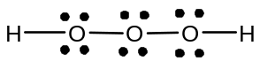 | 
 | B | 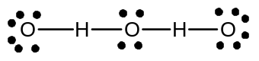 | 
 | C |  | 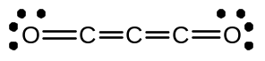
 | D |  | 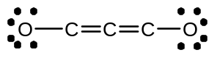

8 | A solid Z has the following physical properties.  - It is insoluble in hydrocarbon solvents.  - It melts at 1290 °C.  - It conducts electricity in both aqueous and molten states.  What is the likely structure of Z?
 | A | an ionic crystal
 | B | an atomic crystal
 | C | a molecular crystal
 | D | a giant molecular lattice

9 | Trimethoprim (TMP) is used for the treatment of urinary tract infections. It has the following structure:  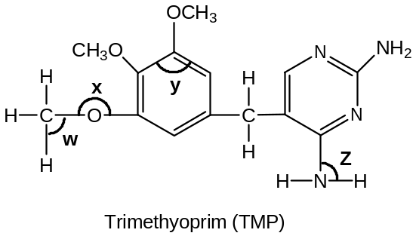  In which sequence is the bond angles quoted in decreasing order?
 | A | y > w > z > x
 | B | x > y > z > w
 | C | y > z > w > x
 | D | x > y > w > z

10 | The bond dissociation energy of H–F is 565 kJ mol^{–1}. Which equation correctly describes the reaction whereby 565 kJ of energy is released?
 | A | HF(l) → HF(g)
 | B | H(g) + F(g) → HF(g)
 | C | HF(g) → H(g) + F(g)
 | D | ½ H₂(g) + ½ F₂(g) → HF(g)

11 | When 13.08 g of zinc dust is added to 250 cm³ of 1.0 mol dm^{–3} aqueous copper(II) sulfate, the temperature rises by 15 °C. The specific heat capacity of the final solution is  4.20 J g^{–1} K^{–1}.  Cu²⁺ + Zn → Zn²⁺ + Cu  What is the enthalpy change for the above reaction?
 | A | –4.12 kJ mol^{–1} | B | –66.3 kJ mol^{–1} | C | –78.8 kJ mol^{–1} | D | –82.9 kJ mol^{–1}

12 | Given the following data and energy cycle:  N₂O₄(g) → 2NO₂(g) ∆H^{θ} = +57.9 kJ mol^{–1}  NO(g) + O₂(g) → NO₂(g) ∆H^{θ} = −56.6 kJ mol^{–1}  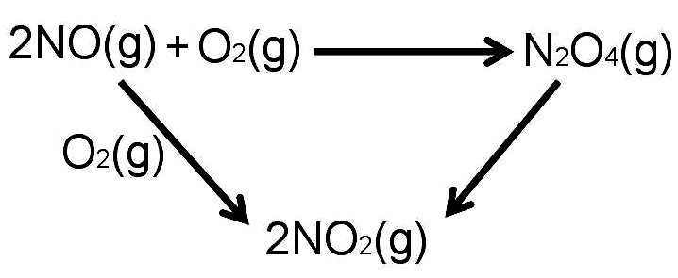  Determine the enthalpy change of the following reaction:  2NO(g) + O₂(g) → N₂O₄(g)
 | A | +114.5 kJ mol^{–1} | B | −114.5 kJ mol^{–1} | C | +171 kJ mol^{–1} | D | −171 kJ mol^{–1}

13 | Which one of the following statements is correct about a reaction for which the equilibrium constant is independent of temperature?
 | A | Its rate constant does not vary with temperature.
 | B | The activation energies for both the forward and reverse reactions are zero.
 | C | The enthalpy change of reaction is zero.
 | D | There are equal number of moles of reactants and products.

14 | The energy diagram represents a reaction that occurs in the absence, and in the presence of a catalyst.  Reaction pathway  Energy / kJ mol^{–1}  Products  Reactants  E₁  E₄  E₂  E₃  Which one of the following statement is correct?
 | A | E₄ is the activation energy for the reverse catalysed reaction.
 | B | The forward catalysed reaction is endothermic.
 | C | The enthalpy change of the forward reaction is (E₂–E₃).
 | D | The enthalpy change of reaction is decreased by using a catalyst.

15 | The graphs below show the variation of the percentage of gaseous products present at equilibrium, with temperature and pressure.  Pressure  % products  at equilibrium  T₂ °C  T₁ °C  T₂ < T₁  Which one of the following systems could the graphs represent?
 | A | N₂(g) + 3H₂(g) 2NH₃(g) ΔH = –92 kJ mol^{–1}
 | B | 3O₂(g) + 4NH₃(g) 2N₂(g) + 6H₂O(g) ΔH = –1248 kJ mol^{–1}
 | C | 2N₂(g) + O₂(g) 2N₂O (g) ΔH = +82 kJ mol^{–1}
 | D | CO₂(g) + C(s) 2CO (g) ΔH = +173 kJ mol^{–1}

16 | One enzyme operates at maximum efficiency when in an aqueous solution buffered at pH 5. Which combination of substances, when dissolved in 12 dm³ of water, would give the necessary buffer solution?
 | A | 1 mol of HCl and 1 mol of CH₃CO₂Na
 | B | 2 mol of CH₃CO₂H and 1 mol of NaOH
 | C | 2 mol of NH₃ and 1 mol of CH₃CO₂NH₄
 | D | 2 mol of NaOH and 1 mol of CH₃CO₂H

17 | The graph below shows the variation in the boiling points for eight consecutive elements in the Periodic Table, all with atomic number between 10 and 20.  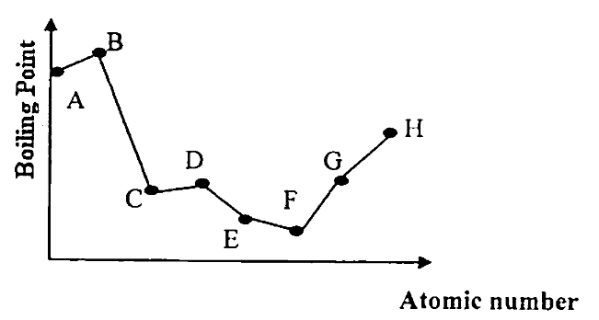  Which of the following can be deduced from the above information?
 | A | Element H and beryllium are in the same group.
 | B | When chloride of element D reacts with water, the solution turns red litmus paper blue.
 | C | Element B conducts electricity in aqueous solution but not in solid state.
 | D | Element A forms a basic oxide only.

18 | An element Z produces a brilliant white flame when burns in air to form oxide of Z. The oxide of Z turns Universal Indicator blue when it is added to water.  What is the element Z?
 | A | Magnesium
 | B | Phosphorus
 | C | Silicon
 | D | Sodium

19 | A compound X exhibits structural isomerism, the isomers being members of different homologous series.  To which pair of isomers could X belong?
 | A | carboxylic acids and esters.
 | B | acylchlorides and carboxylic acids.
 | C | amino acids and ammonium salts.
 | D | amides and amino acids.

20 | A compound used in optical brightener in detergents has the following formula.
 | 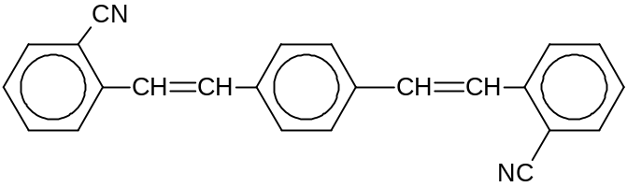
 | Which of the following is likely to be a property of this compound?
 | A | It is readily soluble in water.
 | B | The molecules exist as cis–trans isomers.
 | C | It is hydrolysed by hot dilute sulfuric acid to give an amine.
 | D | It requires 4 mol of hydrogen gas for reduction.

21 | The first stage of the cumene process for the industrial production of phenol is as follows.  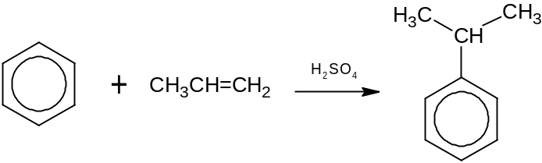  Which one of the following would be the product of reaction, under similar conditions, between benzene and cyclohexene?
 | A | 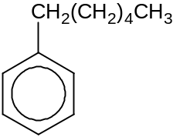 | B | 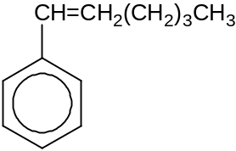 | C | 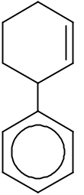 | D | 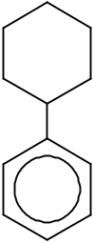

22 | Methylbenzene gives the compound 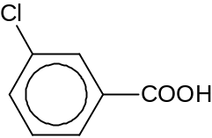 as the product under suitable reacting conditions.  What are the types of reactions taking place?
 | A | electrophilic substitution and oxidation
 | B | electrophilic substitution and reduction
 | C | nucleophilic substitution and oxidation
 | D | nucleophilic substitution and reduction

23 | Deuterium, D, is a heavy isotope of hydrogen. Deuteriobenzene is reacted with a mixture of chlorine gas under suitable conditions such that only monosubstitution takes place.  Assuming that the carbon–deuterium bond is broken as easily as a carbon–hydrogen bond, which proportion of the chlorinated products will be 3–chlorodeuteriobenzene?  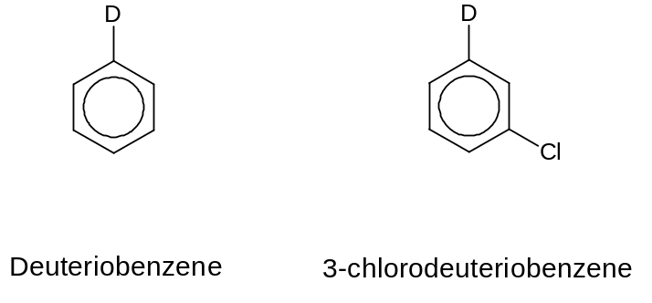
 | A | 16% | B | 20% | C | 33% | D | 45%

24 | Hot ethanolic sodium hydroxide is added separately to two compounds C₆H₅CH₂Br and C₆H₅CH₂CH₂Br to form compound P and Q respectively. What are the structural formulae of compounds P and Q?
 |  | P Q
 | A | 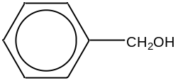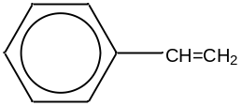
 | B | 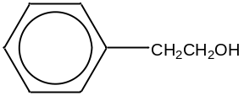
 | C | 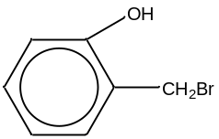
 | D | 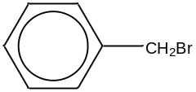

25 | One mole of a compound T reacts with two moles of Na and one mole of Na₂CO₃. Which of the following could be compound T?
 | A | HOCH₂CH₂CO₂H
 | B | HCO₂CH₂CH₂OH
 | C | HOCH₂CH₂COCH₃
 | D | HOCH₂CH(OH)CO₂H

Section B

For each question, one or more of the three numbered statements 1 to 3 may be correct.

Decide whether each of the statements is or is not correct (you may find it helpful to put a tick against the statements which you consider to be correct).

The responses A to D should be selected on the basis of
A | B | C | D
1, 2 and 3  are correct | 1 and 2 only  are correct | 2 and 3 only  are correct | 1 only  is correct

No other combination of statements is used as a correct response.

26 | Which of the following species can be represented by the electronic configuration 1s²2s²2p⁶3s²3p³?
 | 1 | S⁺ ion.
 | 2 | P atom.
 | 3 | Ar– ion.

27 | The graph shows the results of an investigation of the initial rate of hydrolysis of maltose by the enzyme amylase. In the experiments, the initial concentration of maltose is varied but that of amylase is kept constant.  Initial reaction rate  [maltose]  Which conclusions can be deduced from the results?
 | 1 | When [maltose] is low, the rate is first order with respect to [maltose].
 | 2 | When [maltose] is high, the rate is independent of [maltose].
 | 3 | When [maltose] is high, the rate is independent of [amylase].

The responses A to D should be selected on the basis of
A | B | C | D
1, 2 and 3  are correct | 1 and 2 only  are correct | 2 and 3 only  are correct | 1 only  is correct

No other combination of statements is used as a correct response.

28 | The diagram shows some laboratory apparatus:  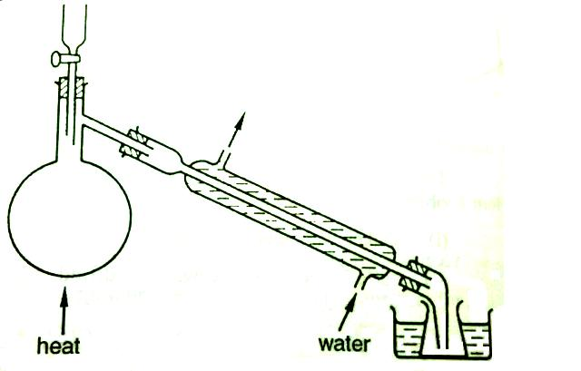  Which preparations could this apparatus be used for?
 | 1 | Bromoethane, from ethanol, sodium bromide and concentrated sulfuric acid.
 | 2 | Ethanal, from ethanol, sodium dichromate(VI) and sulfuric acid.
 | 3 | 1,2–dibromoethane, from bromine and ethene.

29 | Lactic acid builds up in muscles when oxygen is in short supply. It can cause muscular pain. Part of the reaction sequence is shown.  CH₂OHCH(OH)CHO → CH₃COCO₂H → CH₃CH(OH)CO₂H  glyceraldehyde pyruvic acid lactic acid  Which statements about the reaction sequence are correct?
 | 1 | A secondary alcohol is oxidised to a ketone.
 | 2 | A ketone is reduced to a secondary alcohol.
 | 3 | An aldehyde is oxidised to a carboxylic acid.

The responses A to D should be selected on the basis of
A | B | C | D
1, 2 and 3  are correct | 1 and 2 only  are correct | 2 and 3 only  are correct | 1 only  is correct

No other combination of statements is used as a correct response.

30 | Deuterium, D, is a heavy isotope of hydrogen. Which of the following reactions will incorporate D in the final organic product?
 | 1 | CH₃COOCH₂CH₃ + hot aqueous NaOD
 | 2 | CH₂=CH₂ + Br₂ (in D₂O)
 | 3 | CH₃COCH₃ + DCN

DHS H1 CHEMISTRY YEAR 6 PRELIMINARY EXAMINATION 2010
Paper 1 MCQ – Answers

1 | 2 | 3 | 4 | 5 | 6 | 7 | 8 | 9 | 10 |  | 11 | 12 | 13 | 14 | 15 | 16 | 17 | 18 | 19 | 20
C | B | D | D | C | B | C | A | A | B |  | C | D | C | C | B | B | A | A | A | B
21 | 22 | 23 | 24 | 25 | 26 | 27 | 28 | 29 | 30
D | A | C | A | A | B | B | B | C | C

